**Scenario 1:** The bank wants to apply a discount to loan interest rates for customers above 60 years old.

**Question:** Write a PL/SQL block that loops through all customers, checks their age, and if they are above 60, apply a 1% discount to their current loan interest rates.

**QUERY:**

DECLARE

v_age NUMBER;

BEGIN

FOR rec IN (

SELECT c.CustomerID, c.DOB, l.LoanID, l.InterestRate

FROM Customers c

LEFT JOIN Loans l ON c.CustomerID = l.CustomerID

) LOOP

v_age := TRUNC(MONTHS_BETWEEN(SYSDATE, rec.DOB) / 12);

IF v_age > 60 THEN

IF rec.LoanID IS NOT NULL THEN

UPDATE Loans

SET InterestRate = rec.InterestRate - 1

WHERE LoanID = rec.LoanID;

INSERT INTO Loan_Update_Logs (CustomerID, Age, LoanChanged)

VALUES (rec.CustomerID, v_age, 'Loan Rate Reduced');

ELSE

INSERT INTO Loan_Update_Logs (CustomerID, Age, LoanChanged)

VALUES (rec.CustomerID, v_age, 'Eligible - No Loan Found');

END IF;

ELSE

INSERT INTO Loan_Update_Logs (CustomerID, Age, LoanChanged)

VALUES (rec.CustomerID, v_age, 'No Change in Loan');

END IF;

END LOOP;

COMMIT;

END;

/

**OUTPUT:**

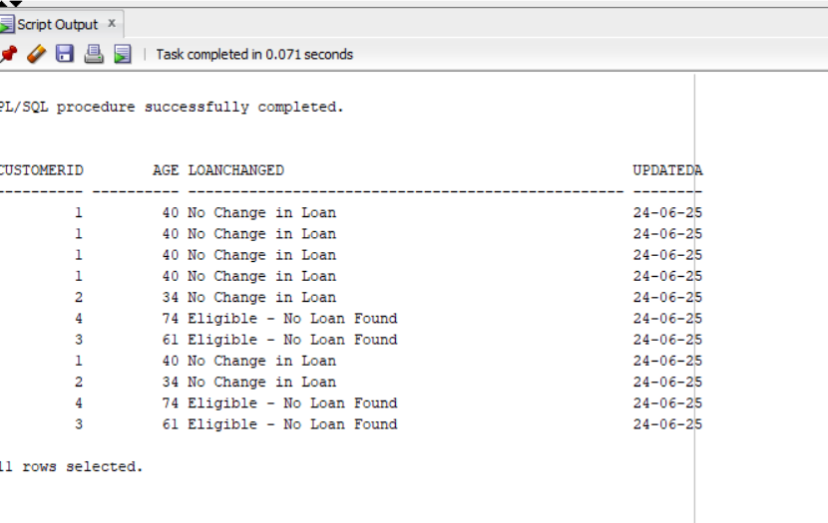

**Scenario 2:** A customer can be promoted to VIP status based on their balance.

**Question:** Write a PL/SQL block that iterates through all customers and sets a flag IsVIP to TRUE for those with a balance over $10,000.

**QUERY:**

BEGIN

FOR rec IN (SELECT CustomerID, Balance FROM Customers) LOOP

IF rec.Balance > 10000 THEN

UPDATE Customers

SET IsVIP = 'TRUE'

WHERE CustomerID = rec.CustomerID;

ELSE

UPDATE Customers

SET IsVIP = 'FALSE'

WHERE CustomerID = rec.CustomerID;

END IF;

END LOOP;

COMMIT;

END;

/

SELECT CustomerID, Name, Balance, IsVIP FROM Customers;

**OUTPUT:**

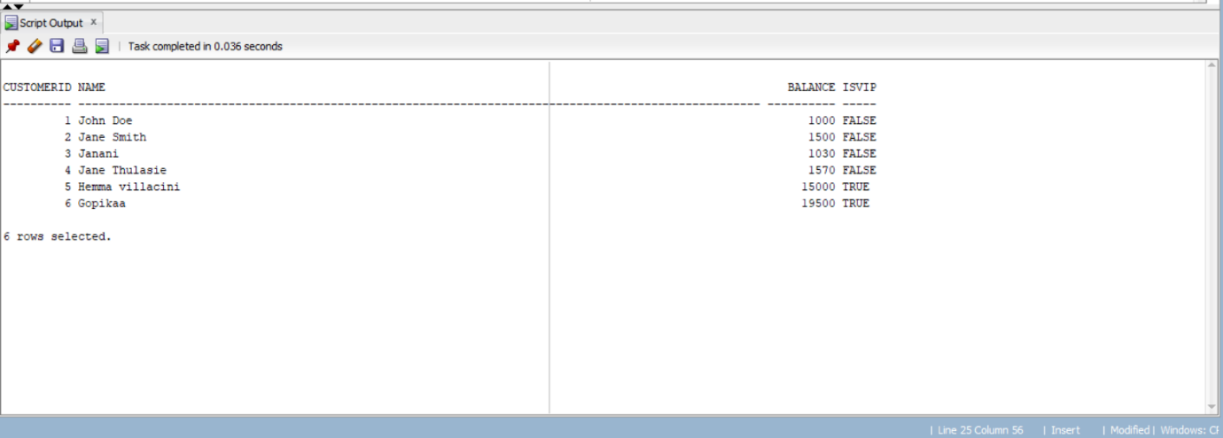

**Scenario 3:** The bank wants to send reminders to customers whose loans are due within the next 30 days.

**Question:** Write a PL/SQL block that fetches all loans due in the next 30 days and prints a reminder message for each customer.

**QUERY:**

SET SERVEROUTPUT ON;

DECLARE

CURSOR due_loans_cur IS

SELECT l.LoanID, l.CustomerID, l.EndDate, c.Name

FROM Loans l

JOIN Customers c ON l.CustomerID = c.CustomerID

WHERE l.EndDate BETWEEN SYSDATE AND SYSDATE + 30;

BEGIN

FOR rec IN due_loans_cur LOOP

DBMS_OUTPUT.PUT_LINE('Reminder: Dear ' || rec.Name ||

', your loan (Loan ID: ' || rec.LoanID ||

') is due on ' || TO_CHAR(rec.EndDate, 'DD-MON-YYYY') ||

'. Please ensure timely payment.');

END LOOP;

END;

/

**OUTPUT:**

